Create the following network.

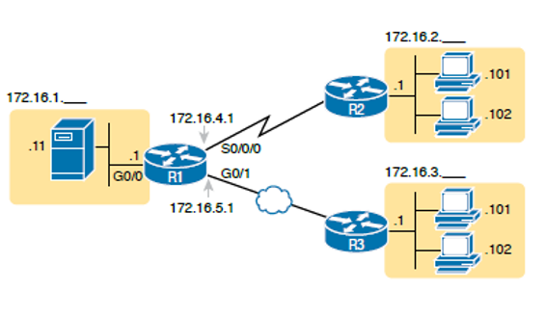

1. Perform static routing and check the PDU status.
2. Perform RIP now.
3. Perform EIGRP now.
4. Perform OSPF now.